Oyster bingo!

- Read the fact sheet and fill in the squares below with six oyster facts.
- Listen to the questions and put a tick in the box next to each correct answer. Don’t forget to shout ‘bingo!’ when you have ticked off all six facts.

- Complete the follow sentence: Adaptations are or that help a species to

- Read the Oyster Adaptations sheet and draw lines below to link the adaptations with how they help oysters survive.
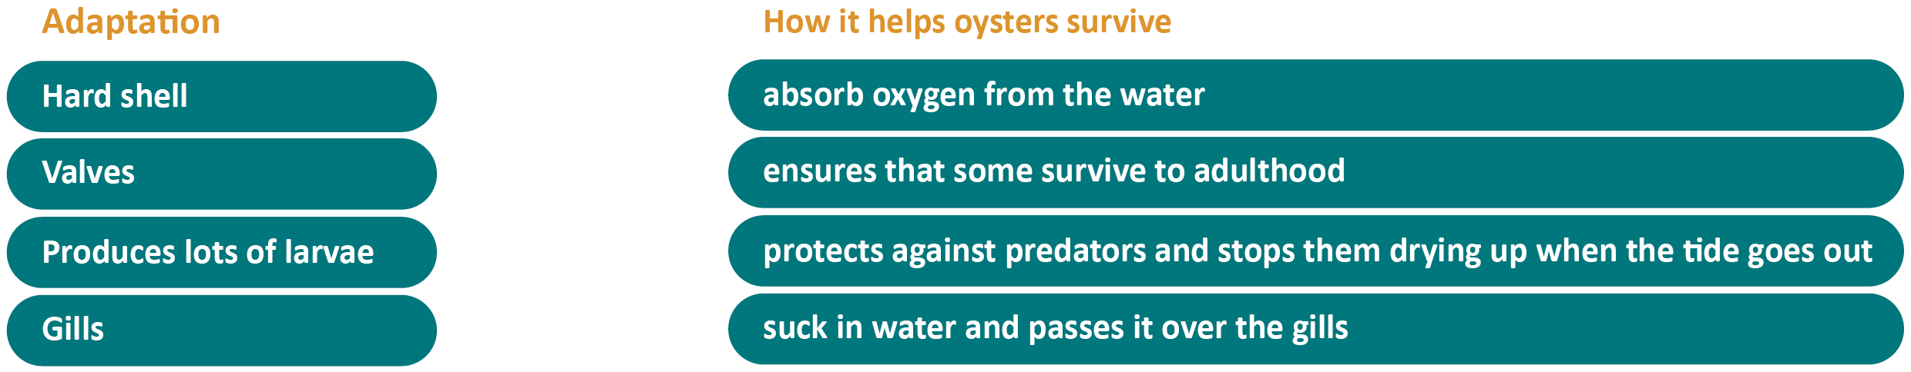
- Extra task: Write down, in your own words, why oysters are amazing.

