Oyster bingo!

Read the fact sheet and fill in the squares below with six of your favourite oyster facts.
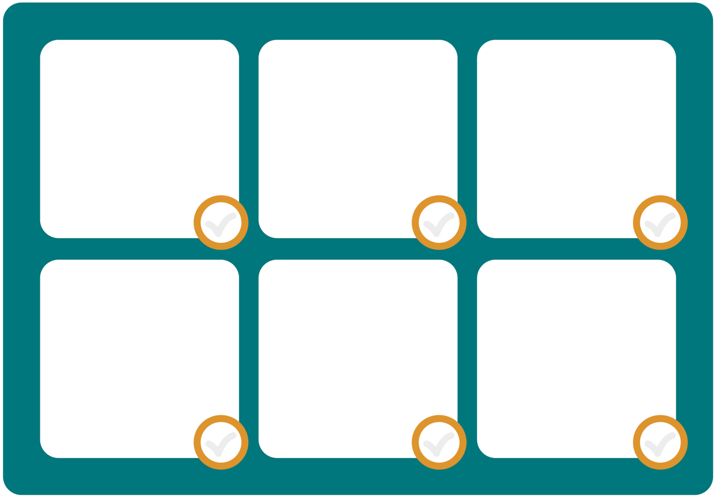
Listen to the questions and put a tick in the box next to each correct answer.
Don’t forget to shout ‘bingo!’ when you have ticked off all six facts.
Extra task:
Write down, in your own words, why oysters are amazing.

